**Name (Last, First): Carganico Mattia**

**Name (Last, First): --------------------------**

**Name (Last, First): --------------------------**

***For full marks, please provide complete solutions in the space provided for each question. Values for z, t, and probabilities (when appropriate) MUST come from the tables provided in class (on eCentennial). Any other values will not be considered correct and will result in a mark of zero.***

***Late assignments will not be accepted.***

1. A study including high school students found that students buy lunch from outside 12% of the times. If 24 students are randomly selected, find the following probabilities: (***Express your answers correct to 4 decimal places)***
2. Exactly 4 buys lunch from outside. [2 marks]
3. At most 2 buys lunch from outside. [3 marks]
4. Find the mean [1 mark]
5. Find standard deviation [1 mark]

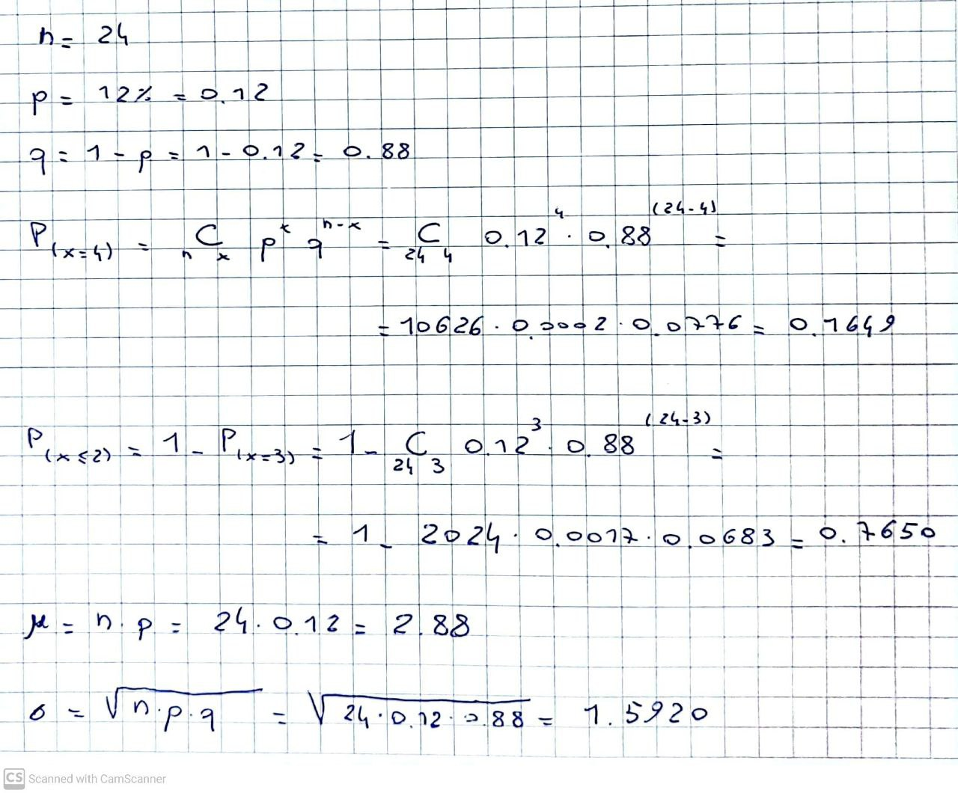

1. In an experiment of fries’ preference, a chef selects three random orders, one at a time and notes down customers request of potato fries or sweet potato fries and counts the number of times potato fries are selected. ***(For questions c and d express your answer correct to two decimal places)***
2. State the random variable and create the sample space [2 marks]
3. Create a table showing the probability distribution for the number of times potato fries are selected. [2 marks]
4. Find the mean for this distribution. [2 marks]
5. Find the standard deviation for this distribution. [2 marks]

1. Study shows that the teenagers spend on average 8.7 hours per week on playing sports with a standard deviation of 1.9. If the time spent on sports is approximately normally distributed, determine:
2. The probability that their weekly time spent is between 6.9 and 9.5 hrs. [3 marks]

1. The time that separates the top 32% of the time spent from the bottom of the 68% of the time per week. Round answer to one decimal place. [3 marks]

1. If 36 teenagers are randomly selected, what is the probability that the mean of their weekly time spent on sports is greater than 8.5 hours? [3 marks]

1. In a study asking 37 couples about their average weekly spending on fast food is $ 87.5 with a standard deviation of $6.3. Find a 98% confidence interval for the population mean of the weekly spending on fast food per couple. (***Express your answer correct to 2 decimal places)***. [3 marks]
2. Average life expectancy of types of dogs is 13.9 years with a standard deviation being 1.1 years. It is thought that the mean has changed but the standard deviation has remained the same. How many dogs should be surveyed to be able to estimate the new mean by the sample mean with maximum error of estimate 0.1 years and a 90% level of confidence? [3 marks]